**Past: How the British Empire used to be**

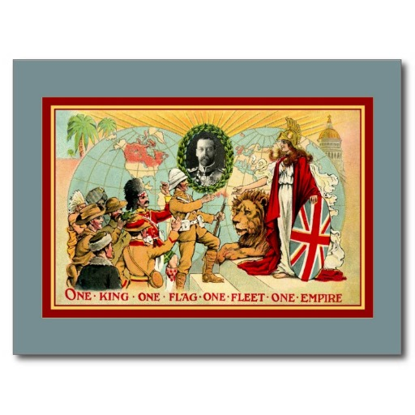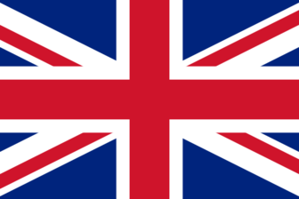 _ _ _ _ _ _ _ _ _ _ _ _ _ _ _ _ _ _ _ _ _ _ _ _ _ _ _ _ _ _ _

_ _ _ _ _ _ _ _ _ _ _ _ _ _ _ _ _ _ _ _ _ _ _ _ _ _ _ _ _ _ _ _ _

_ _ _ _ _ _ _ _ _ _ _ _ _ _ _ _ _ _ _ _ _ _ _ _ _ _ _ _ _ _ _ _ _

 C’est une image de l’empire britannique,

en 1921

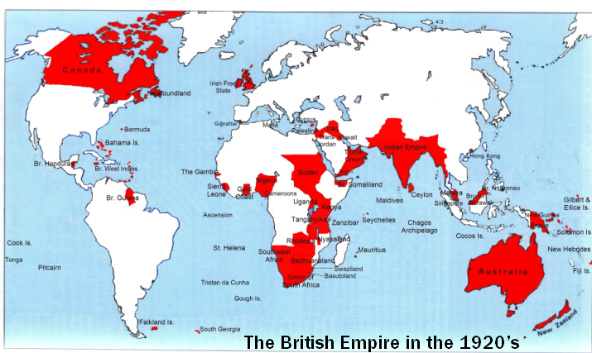

**1921**: **The British Empire**

**First world power**

**Population: _ _ _ _ _ _ _ _ _ _ _ _ _ _ _ _ _ _ _ _ _**

**Territory:** a quarter of the Earth's territory

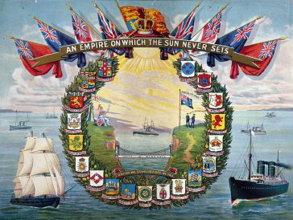

**Present: The United Kingdom today**

**OFFICIAL NAME**: **the United Kingdom of Great Britain and Northern Ireland**

**MONARCH**: _ _ _ _ _ _ _ _ _ _ _ _ _ _ __ _ _ _ _ _ _ _ _ _ _ _ _ _ _ _ _ _ _ _ _ _ _ _ _ _ _ _ _ _ _ _ _ _ _ _ _ _ _ _ _

**PRIME MINISTER:** _ _ _ _ _ _ _ _ _ _ _ _ _ _ _ _ _ _ _ _ _ _ _ _ _ _ _ _ _ _ _ _ _ _ _ _ _ _ _ _ _ _ _ _ _ _ _ _ _ _ _

**CAPITAL CITY**: _ _ _ _ _ _ _ _ _ _ _ _ _ _ _ _ _ _ _ _ _ _ _ _ _ _ _ _ _ _ _ _ _ _ _ _ _ _ _ _ _ _ _ _ _ _ _ _ _ _ _ _ _

**POPULATION**: _ _ _ _ _ _ _ _ _ _ _ _ _ _ _ _ _ _ _ _ _ _ _ _ _ _ _ _ _ _ _ _ _ _ _ _ _ _ _ _ _ _ _ _ _ _ _ _ _ _ _ _ _ _

**OFFICIAL LANGUAGE**: _ _ _ _ _ _ _ _ _ _ _ _ _ _ _ _ _ _ _ _ _ _ _ _ _ _ _ _ _ _ _ _ _ _ _ _ _ _ _ _ _ _ _ _ _ _ _ _ _

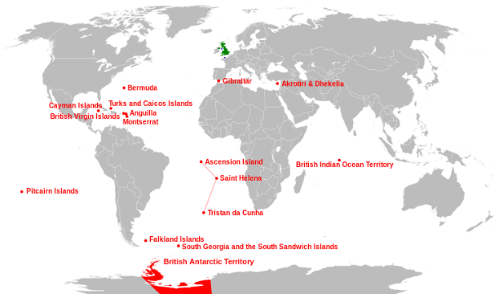**Currency**: The currency used in the United Kingdom is _ _ _ _ _ _ _ _ _ _ _ _ _ _ _ _ _ _ _ _ _ _ _ _ _ _ _ _ _



***Today*:**