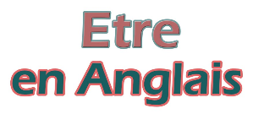**Exercise - “to be”**

**1) Translate into French:**

|  |  |
| --- | --- |
| Drapeau angleterre - Trendyyy.com | Drapeau France 60*90 cm - Drapazur |
| I am (= I’m) |  |
| we are not (= we aren’t) |  |
| he is (= he’s) |  |
| they are (= they’re) |  |
| I am not (= I’m not) |  |
| are we? |  |
| are they? |  |
| is he? |  |
| he is not (= he’s not) |  |
| are you? |  |
| she is not (= she’s not) |  |
| you are (= you’re) |  |
| she is (= she’s) |  |
| we are (= we’re) |  |
| they are not (= they’re not) |  |
| am I? |  |
| is she? |  |
| you are not (= you’re not) |  |

**2) Try to find the right answer:**



